S.T.E.A.M Friday – Design Your Own “Dream Bedroom”

If you had unlimited resources, what would your dream bedroom look like? Would there be a pool? A giant foam pit? A high-tech gaming station? A huge bed? A basketball hoop? An art supply closet?
For your STEAM challenge this week you are asked to create your own dream bedroom!

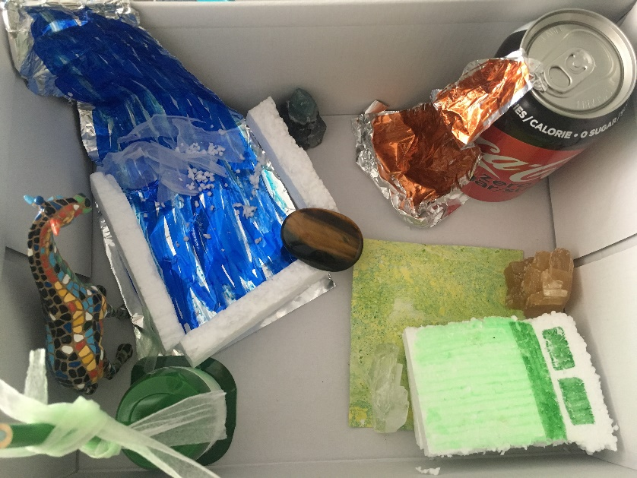
Here’s an example that I created! I used materials I had around my house. I used a shoebox, tin foil, rocks, a yogurt container, Styrofoam, a coke can, paper, and markers!
I included a waterfall pool to swim in. A giraffe friend and tree for it to eat. I have a bed with a rug. I also have a coca cola waterfall, because many of you know my love for that beverage!

- Start with a brainstorm! What could you add in?

- Pick your medium – What will you design with?
- Lego
- Cardboard
- Shoe box
- Paper (If you don’t have supplies to build you can always draw it out!)
- Use whatever items you have in your house that you have permission to use!

- Start building and decorating!

- Measure!
Using a ruler or a referent of your choice measure the perimeter of your dream room!! Do you remember how you can calculate perimeter?
P = L + L + W + W
What is the area of your room?
A = L X W
I didn’t have a ruler, so I used a referent of my pinkie finger to estimate the dimensions of my room!
I counted 25 pinkies by 21 pinkies. That is approximately 25cm by 21cm! That means my perimeter was about 92cm! My area would be about 525 cm²!
Don’t forget to include units in your measurements for perimeter and area!

- Reflect
- Can you describe what you included in your room and why!
  - Ex: I included a waterfall because I love water. Not only is it pretty to look at, I can also swim in it. Additionally, the noise the water creates as it crashes down over the rocks is very soothing and helps me fall asleep.

- What went well in your design and building? What would you do differently next time?

