 | Sunday | Monday | Tuesday |  | Wednesday | Thursday | Friday | Saturday
 | Special Helper |  |  |  |  |  | 1  Class + School Photos  Leo | 2
Themes:  Seeds + Plants | 3 | 4  PE  Buddies  Lior | 5  Max |  | 6  PE  2 pm dismissal  S-L conference  2– 6 pm | 7  Library  Niko | 8  Family Reading  8:50 – 9:15 AM  Olympia | 9
Butterflies | 10 | 11  PE  Ozus | 12  Prem |  | 13  PE  Quinn | 14  Library  Rowan | 15  Sami | 16
Butterflies | 17 | 18  Victoria Day  (No School Today) | 19  Aimé |  | 20  PE  Aliyah | 21  Library | 22  Family Reading  8:50 – 9:15 AM  Avery | 23
Parents’ Day | 24 | 25  Science World  10:30 – 2:30 | 26  Charlie | 27  PE  Ciara |  | 28  Library  Conley | 29  Daisy | 30

Division 21’s May Calendar
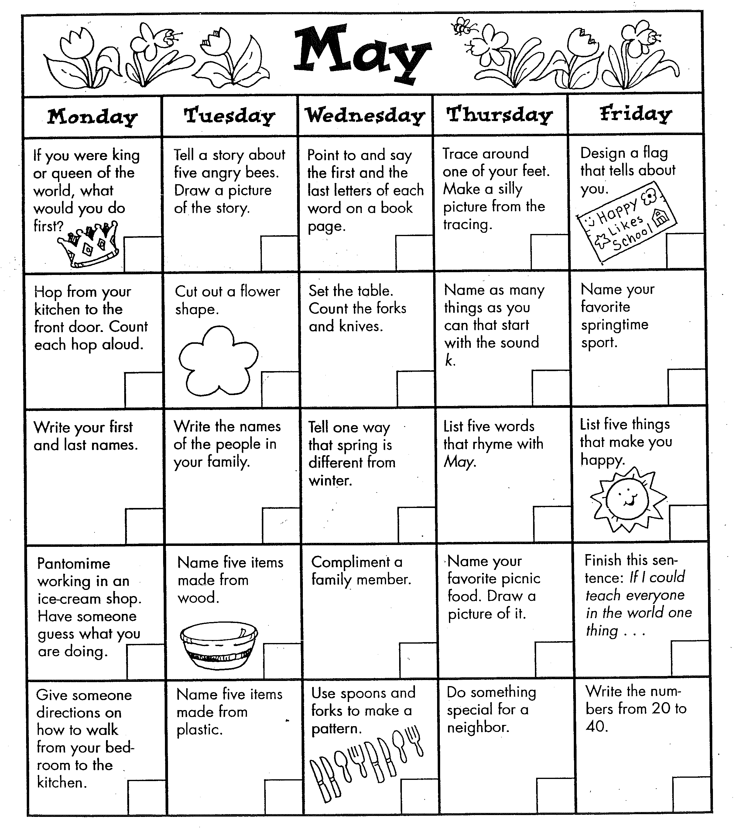

Student-led Conferences (May 6) These conferences take place in an Open House format where several children are in the classroom with their families at the same time. Your child will be leading the conference but some prompting from you will be very helpful. An agenda will be provided.

Community Walks Is anyone interested in having the class walk by their homes to say “Hi!” this month? Our class would love to take 2 or 3 walks in the neighbourhood to learn more about their surrounding community.

Science World (May 25) We will be visiting the Science World to continue our learning about forces and motion. Parent drivers will be leaving the school at 10:30 am and leaving Science World at 2 pm. Please send your child’s car seat, and their snack and lunch in a paper bag with their name on the outside. (No backpacks will be brought.)

