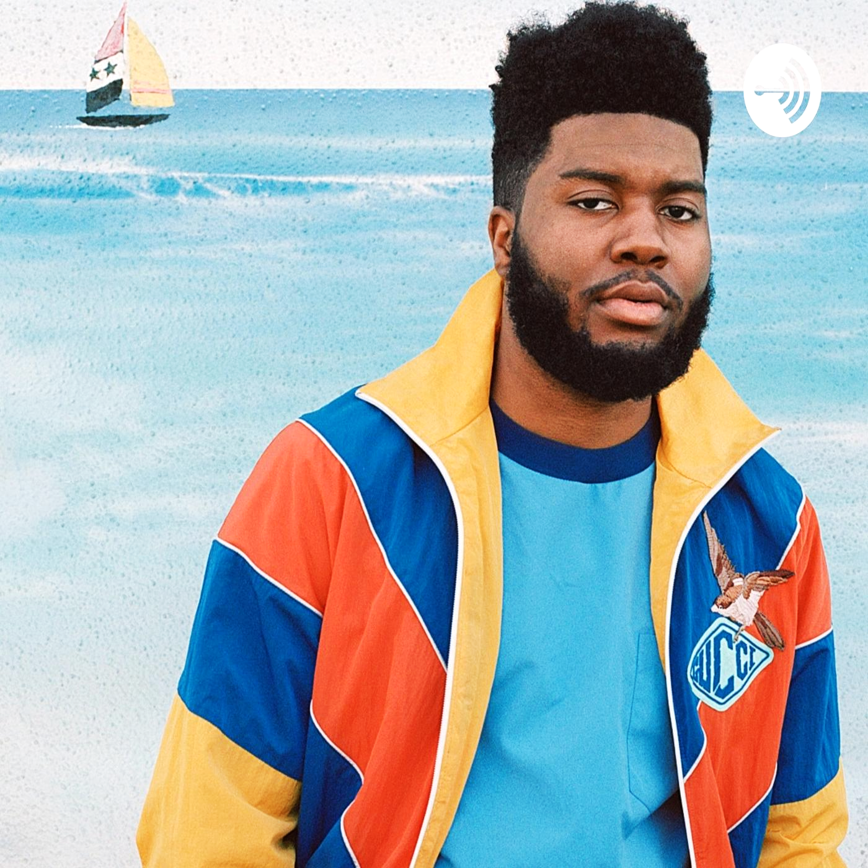
Biography:
Just out of high school when he made his commercial debut with the ballad "Location" (2016), non-traditional R&B singer and songwriter Khalid has attracted a large following with an undemonstrative but heartfelt vocal style and a down-to-earth perspective. Although he attained a major-label contract within months of uploading his first songs, "Location" moved into the mainstream at a slow tempo similar to that of the song itself and became a Top 20 pop hit just after the release of American Teen (2017), one of the biggest album debuts of the late 2010s. Within a period of just over a year, Khalid went from an unknown everyday teenager to a chart-topping, platinum-certified pop star with Grammy nominations for "Location" and American Teen, plus Logic's "1-800-237-8255," on which he appeared.

Early-terms:
Robinson was born in Fort Stewart, Georgia. He spent his childhood in various locations due to his mother, Linda Wolfe, and father's military careers, including Fort Campbell in Kentucky, Fort Drum in Watertown, New York, and six years in Heidelberg, Germany. Wolfe worked as a supply technician and became a member of the Army corps. In high school, Robinson studied singing and musical theater. He attended Carthage Central High School in Carthage, New York for his first three years of high school before he and his mother moved to El Paso, Texas, where he attended Americas High School for his senior year.

Childhood Drama:
Due to her job, they had to move frequently when he was young, and lived in places like Fort Campbell in Kentucky, Fort Drum in Watertown, New York, and in Heidelberg, Germany for six years.
His parents separated when he was very young, and when he was in the second grade, living in Germany with his mother, his father was killed after being hit by a car. His mother later retired from the military at Fort Bliss in El Paso, Texas as a Sergeant First Class.
His mother, who wanted to be an R&B singer back in the 1990s, performed with a U.S. Army band after joining the military due to family issues and often practiced duets with him at home. This paroused his interest in music and prompted him to watch YouTube videos of famous singers like Fleetwood Mac, Adele, Bill Withers, Aaliyah and Father John Misty to learn their style After returning from Germany, the family moved to New York where he performed in musicals in school, playing Cornelius in ‘Hello, Dolly’ and Seaweed in ‘Hairspray’. His musical talent earned him popularity, but also made him a target of bullying.
He attended his high school senior year at Americas High School in El Paso, Texas. He initially thought of becoming a music teacher, but began to write and record songs in high school and uploaded them to his Soundcloud page.

Career :
Some of the early songs that Khalid uploaded on the internet include 'Saved' and 'Stuck On You'. Eager to bring out another song before prom, he managed to contact producer Syk Sense and secured an invitation to work with him in an Atlanta studio.
Khalid began writing and creating music in high school; he posted his early works to SoundCloud. Shortly after graduating from Americas High School, Khalid reached number two on the Billboard Twitter Emerging Artists chart in July 2016. His single "Location" began charting, which led to his being featured in many publications, including Billboard, Yahoo!, BuzzFeed, and Rolling Stone. With production from Syk Sense, Tunji Ige, and Smash David, "Location" finished the year 2016 at number 20 on the US Mainstream R&B/Hip-Hop Airplay chart and reached the Top 10 on the US Hot R&B Songs chart on January 21, 2017. The music video for "Location" premiered on The Fader's website. The album's second single "Young Dumb & Broke" became a sleeper hit, becoming a hit at rhythmic formats and crossing over to pop radio into early 2018.

Value Longevity:
The growth of the cultural aspect on Khalid and personal experience/ stories
Create an interesting moody chill modern feeling, mixed with pop, funk, R&B style
Many collaborations of various styles of simplicity.
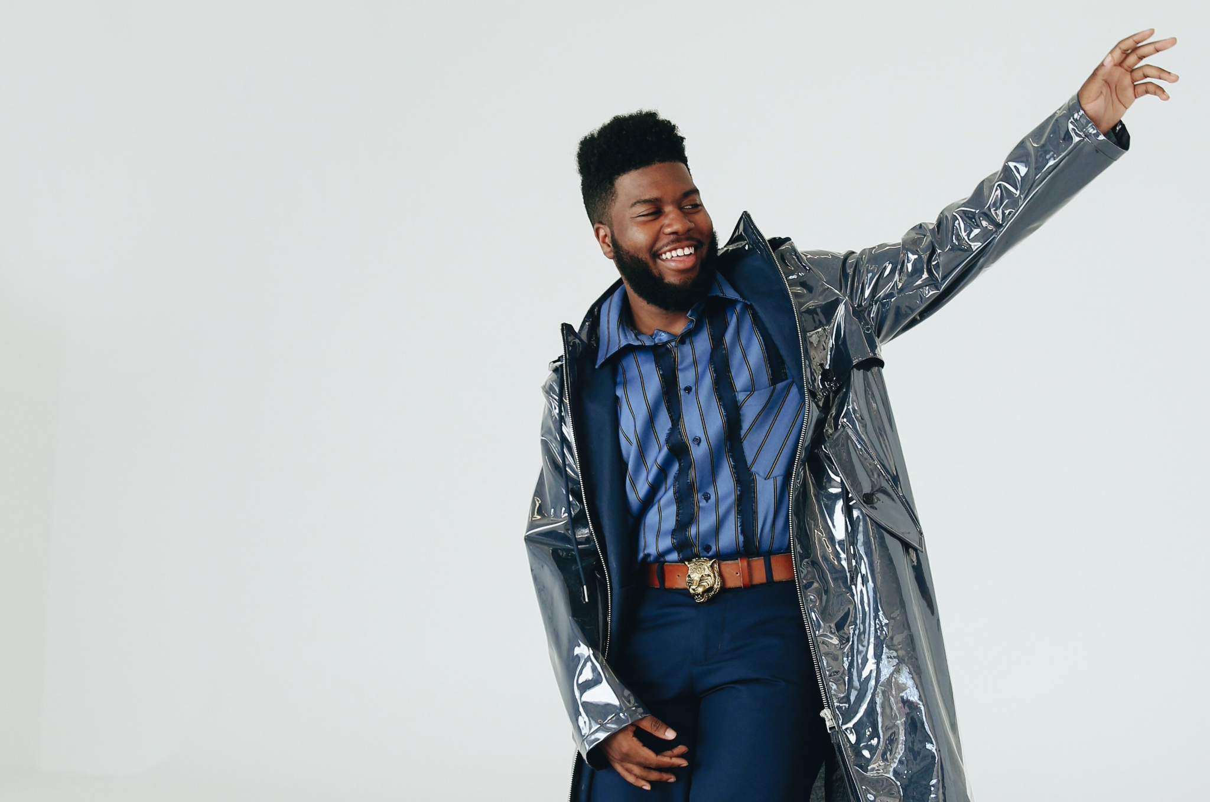
Reproducible:
Khalid’s Success is not luck. It is proof of the creative talents of one's self. His earlier failures with recording companies were a result of marketing and corporate interests. Going on a social media platform had provided him a chance of success; by which made Khalid reach his target audience around the world. This shows the success by which makes it repeatable for talented and persevering artists.
Khalid’s Best Hits 1. lovely (with Khalid) 2. Silence
3. Young Dumb & Broke 4. Location
5. Be Like That - feat. Swae Lee & Khalid 6. Better7. Beautiful People (feat. Khalid)
8. Eastside (with Halsey & Khalid)
9. 8TEEN 10. working
Bibliographies / Information
Khalid Biography and life story. AceShowbiz. (n.d.). Retrieved January 17, 2022, from https://www.aceshowbiz.com/celebrity/khalid/biography.html
Who is Khalid (singer)? everything you need to know. Facts, Childhood, Family Life & Achievements. (n.d.). Retrieved January 17, 2022, from https://www.thefamouspeople.com/profiles/khalid-singer-35580.php
Khalid info. AllMusic. (n.d.). Retrieved January 17, 2022, from https://www.allmusic.com/artist/khalid-mn0000095880/biography
Wikimedia Foundation. (2022, January 13). Khalid (singer). Wikipedia. Retrieved January 17, 2022, from https://en.wikipedia.org/wiki/Khalid_(singer)#:~:text=Career-,2016%E2%80%932017%3A%20American%20Teen,Artists%20chart%20in%20July%202016.

