Tout à propos de ma culture: ______________

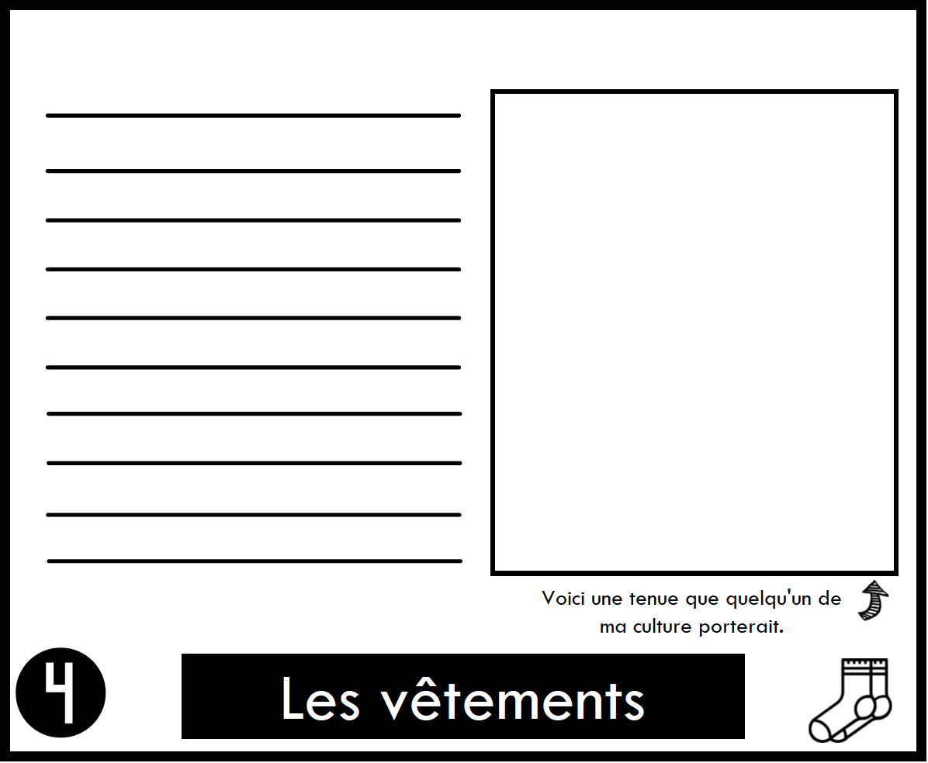

What types of clothing do you wear most days? What types of clothing do you wear for special occasions? Where do these styles come from?

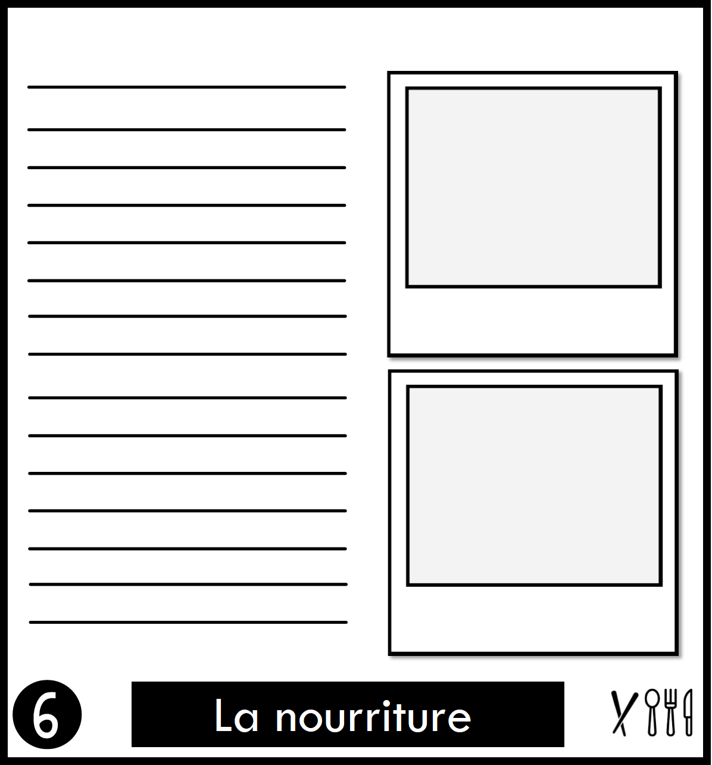

What foods do you eat most often? What foods do you eat for special occasions? Where do the recipes come from?

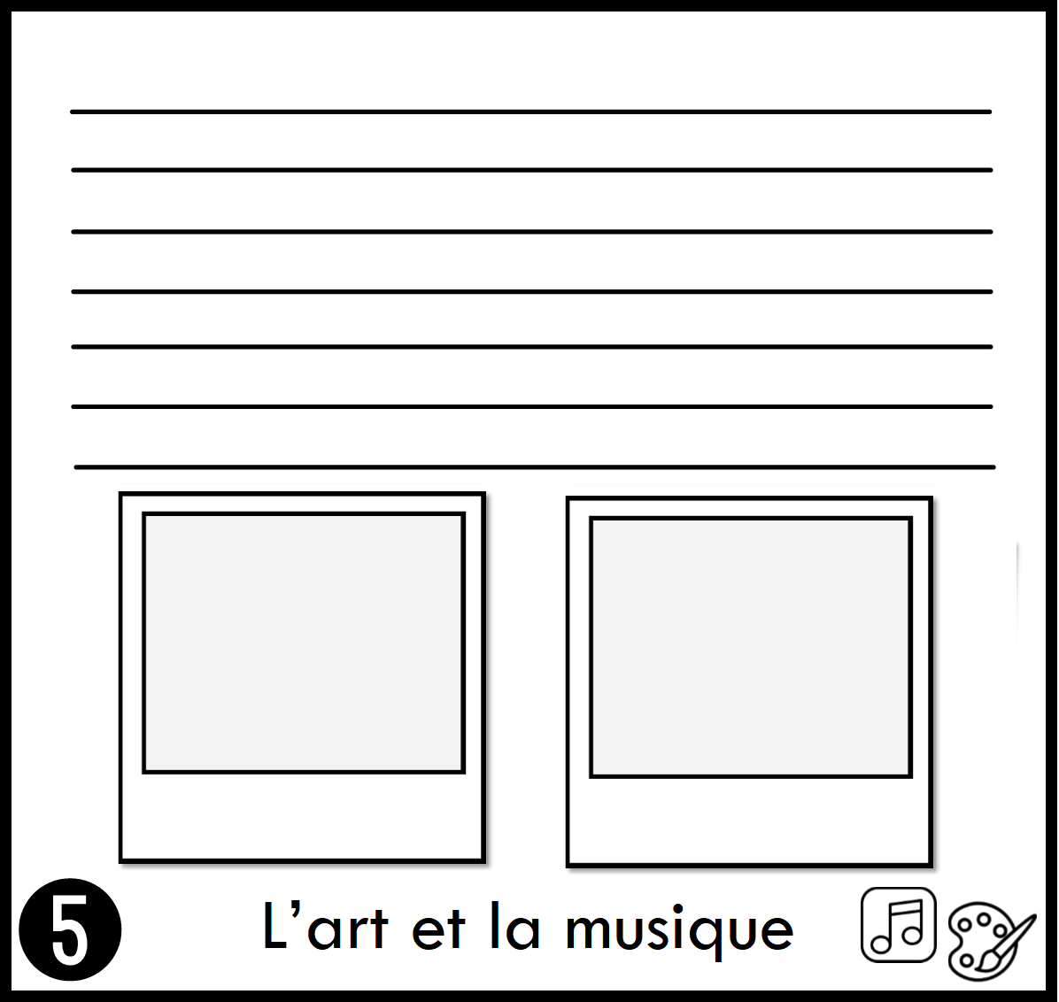

What music do you listen to at home? What kinds of instruments are used to make the music you listen to? Who are some famous musicians you know?

What kinds of art do you see at home or in your community? What materials symbols, patterns or colours are used most often? Who are some famous artists you know?

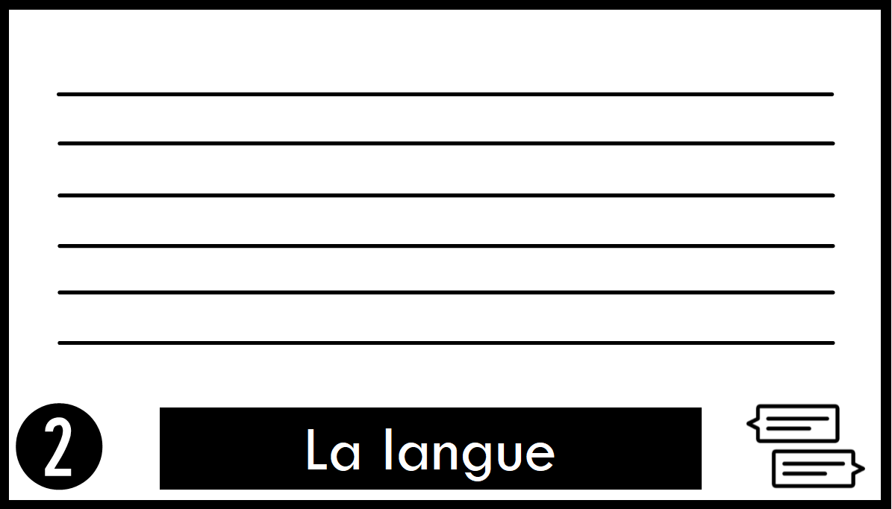

What language(s) do you speak at home?

What language(s) do you speak in the community?

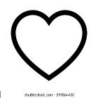

*Please share only what feels comfortable to share with the class.

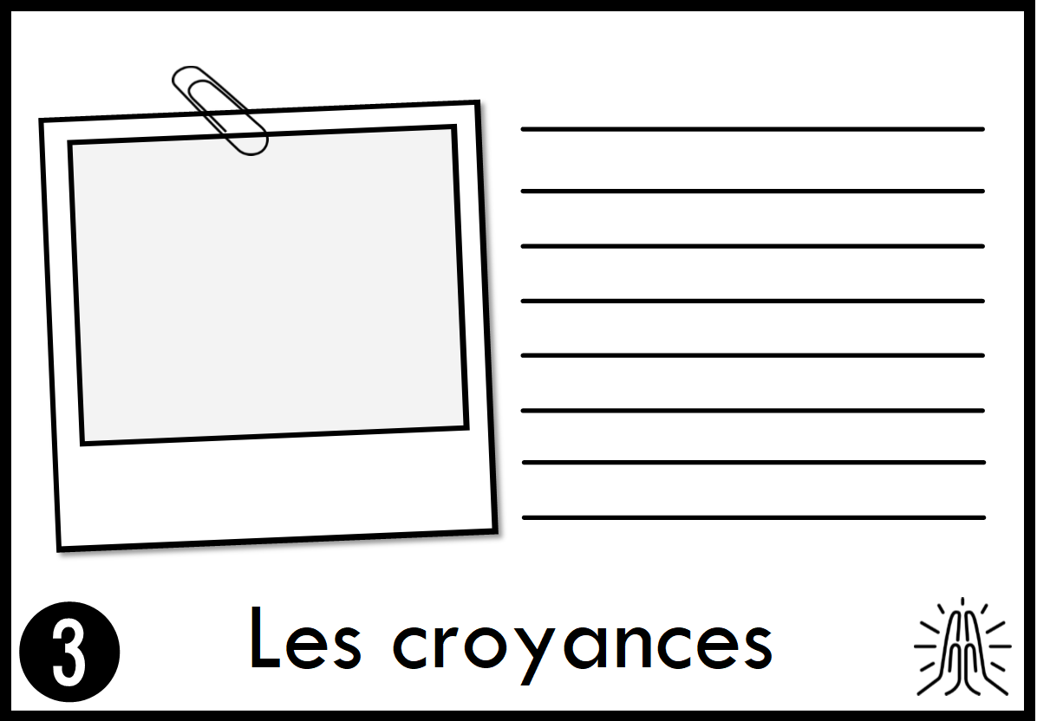

What beliefs do you have as a family, or as individuals? Do you go to a church, mosque, temple, or other place of worship? What values do believe in?

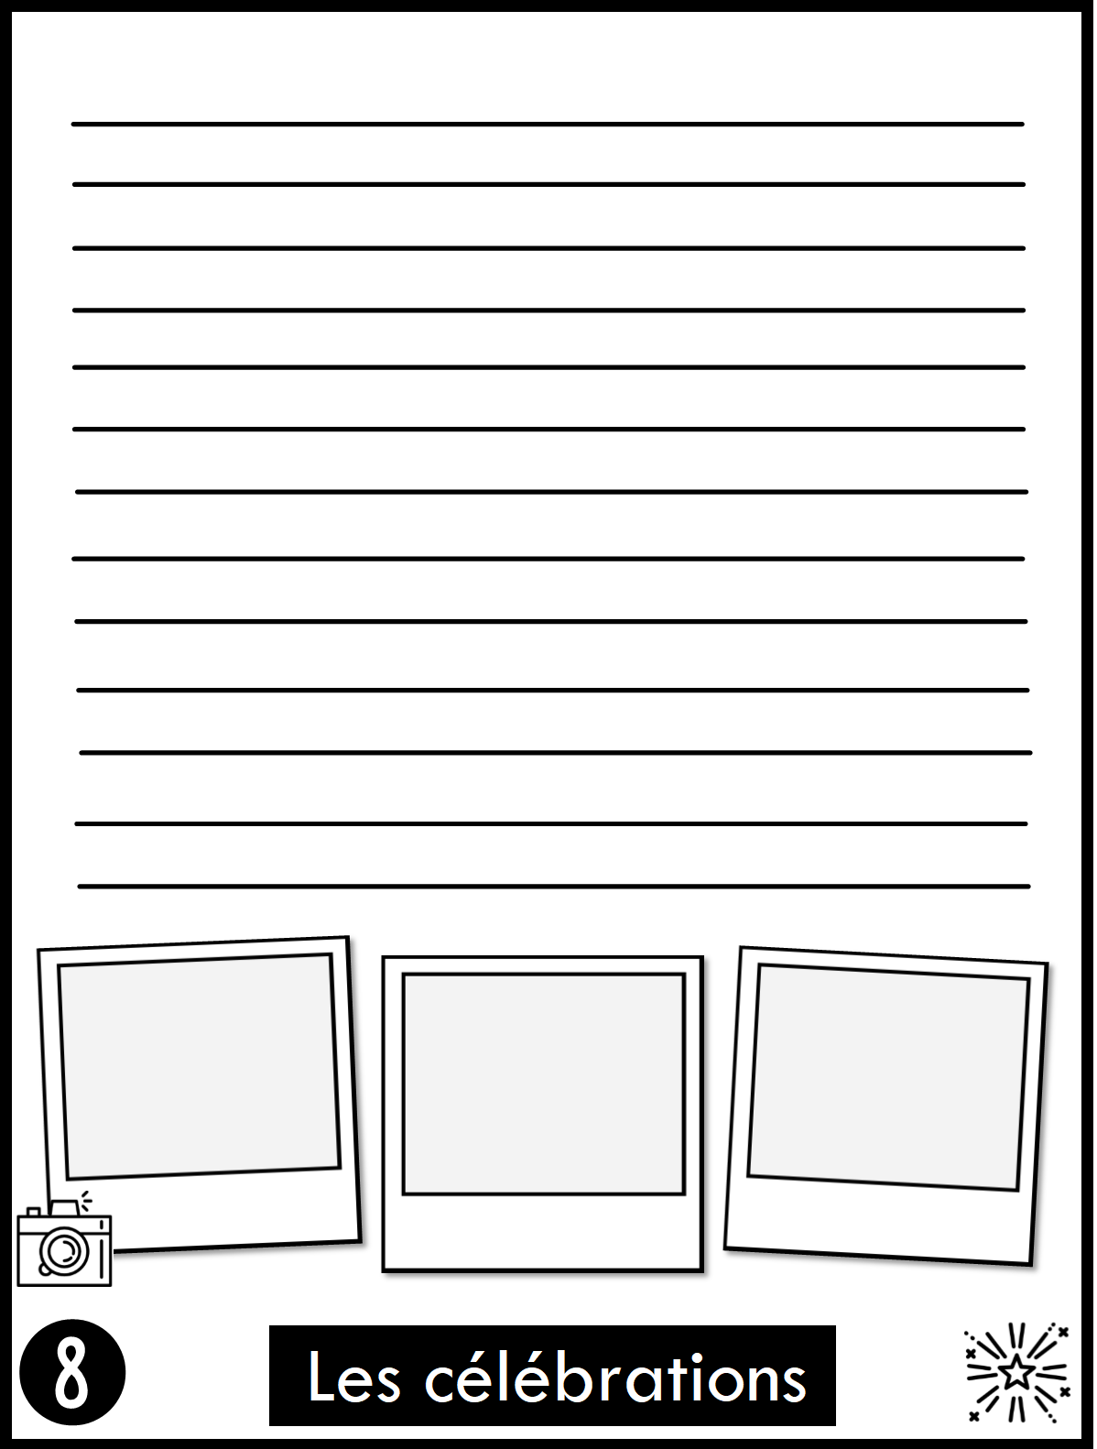

What holidays do you celebrate? What other special occasions do you celebrate? How do you celebrate? (ie: what you do, eat, wear, decorate, etc.)

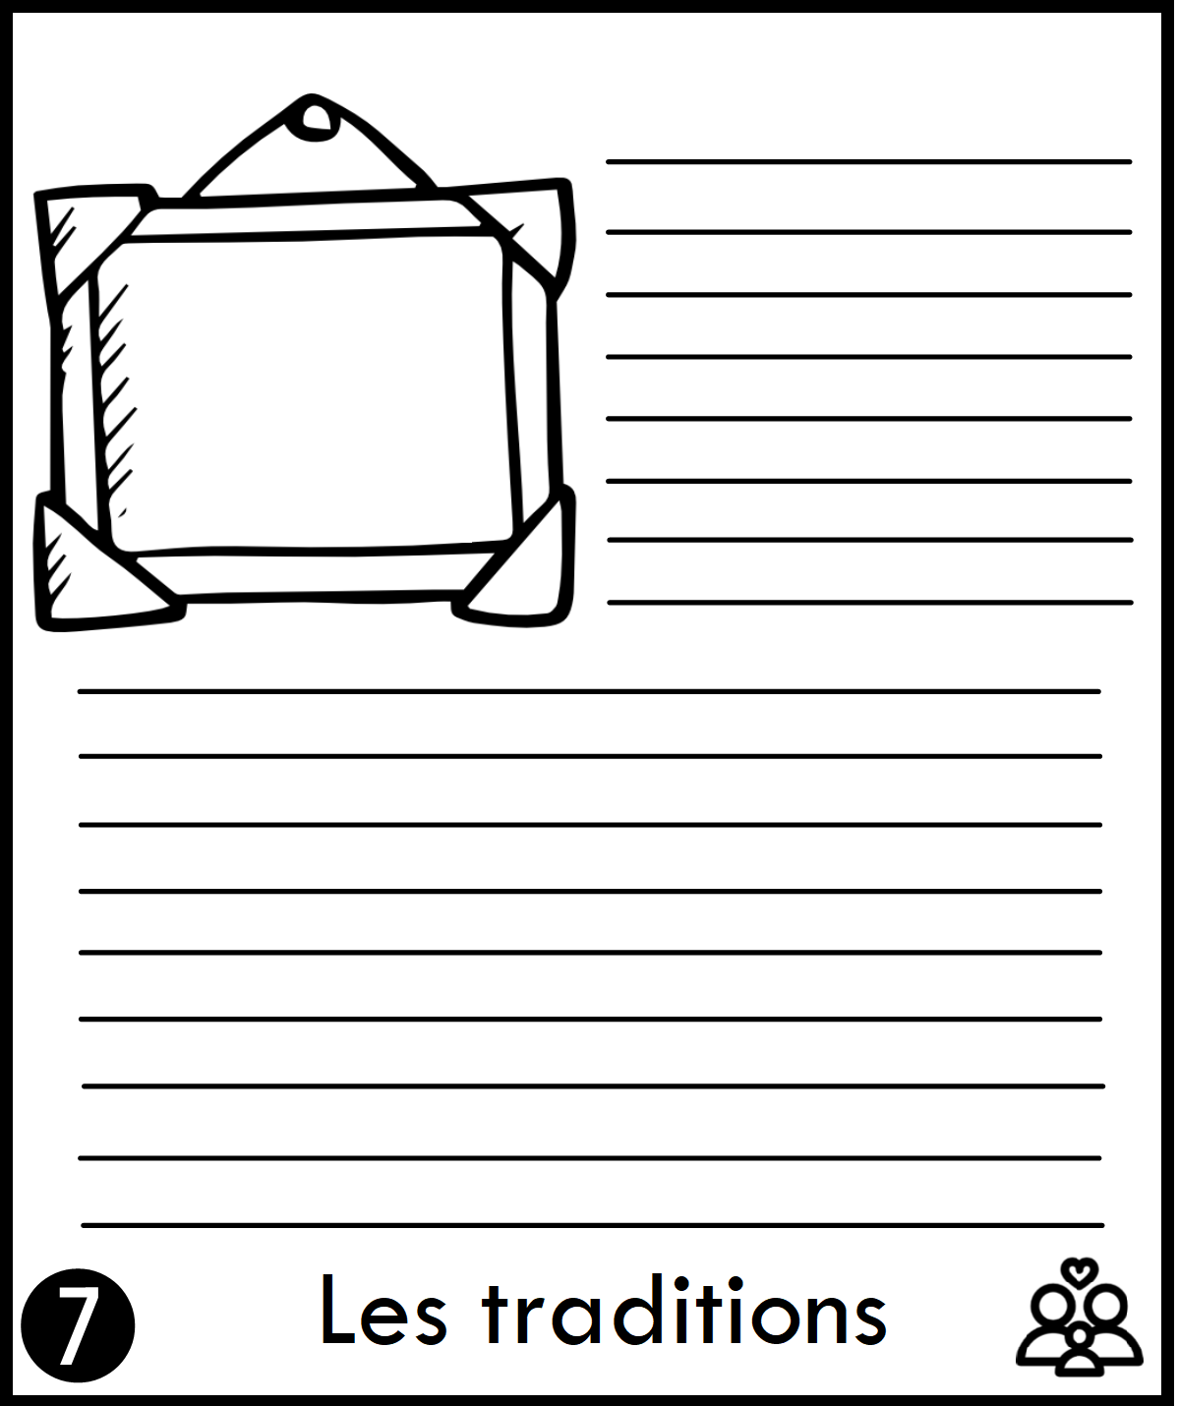

Describe some of the traditions you practice. Where did these traditions come from?